Your position title | Garden Centre Team Member
Your primary department will be  You may be required to work across other departments as needed to support store operations. | Garden Centre Team Member
You’ll be supported by (Report to) | Garden Manager

PURPOSE — HOW YOU’LL HELP INSPIRE KIWIS TO LOVE WHERE THEY LIVE, WORK AND PLAY
Help customers choose plants and garden products by providing practical advice and great service for successful results. Maintain plant health, and presentation, and merchandising standards to make the garden centre inviting, well-stocked, and easy to shop.
YOUR ROLE SCOPE
Number of direct reports: Nil Budget ownership: Nil
- Provide advice on plant selection, care, and seasonal needs; proactively engage customers upsell complementary products.
- Watering, pruning, and pest checks; rotate stock for health and presentation.
- Set up seasonal and promotional displays; ensure accurate ticketing.
- Maintain merchandising standards, including product presentation, ticketing, pricing accuracy, and display execution.
- Replenish stock and maintain product availability, including top-ups and back-of-house stock movement.
- Use in-store systems/devices to check product availability, locations, and alternatives for customers.
- Keep all areas safe and clear, including maintaining safe walkways, hose management, and spill control.
- Support other departments as required to meet customer demand and store priorities.
CORE CAPABILITIES YOU NEED
- Customer focus and clear communication; ability to listen, clarify needs, and guide customers to the right solution.
- Attention to detail and pride in plant health, presentation, and ticketing standards.
- Time management and adaptability across tasks, seasons, and customer demand.
- Teamwork across the garden centre and wider store; reliable and proactive support where needed.
TECHNICAL SKILLS YOU HAVE
- Basic horticultural knowledge; willingness to learn plant care and seasonal requirements.
- Confidence using store systems/devices for stock look-ups, product location, and learning modules.
- Merchandising basics, including ticketing, display standards, and product presentation.
- Inventory and stock processes, including replenishment and stock rotation.
- Safe use of hoses, ladders, and garden equipment; PPE awareness.
WHAT WE EXPECT AT MITRE 10 — WHAT WE ALL DELIVER
Our values guide how we work together, how we serve our customers, and what we expect from each other every day.
Our Values in Action
Customer Obsessed
- Put customers at the heart of decisions and look for ways to make things simple and helpful.
- Be positive and solution focused — say “we can”, not “we can’t”

One Team
- Respect, value and listen to others.
- Make selfless decisions and acknowledge the effort of others.
- Look after each other’s health, safety, and wellbeing.

Honest & Fair
- Communicate openly and share accurate information.
- Treat others as you’d like to be treated and take personal accountability.

Strive for Excellence
- Look for opportunities to improve and learn from mistakes.
- Use sound practical judgement and deliver work you’re proud of.

Customer Experience
- Deliver friendly, solutions-focused service in every interaction.
- Make it easy for customers to get what they need and proactively offer support.

Safety & Escalation
- Follow Health & Safety procedures and use required PPE.
- Be able to perform the inherent requirements of the role in a safe and reliable manner.
- Maintain safe, tidy, environments across all store areas.
- Identify, record, and escalate hazards, risks, near misses, and safety concerns promptly.

Systems, Processes & Compliance
- Use Mitre 10 systems, tools, and equipment safely and responsibly.
- Maintain accurate records, and protect customer and business privacy.
- Follow all relevant policies, procedures, and legislative requirements.
- Complete required training and keep your learning up to date.

Teamwork, Support & Flexibility
- Contribute positively to a collaborative and inclusive team environment.
- Support others to maintain high standards of service, safety, and operational efficiency.
- Adapt to changing priorities and be willing to help in other areas when needed.
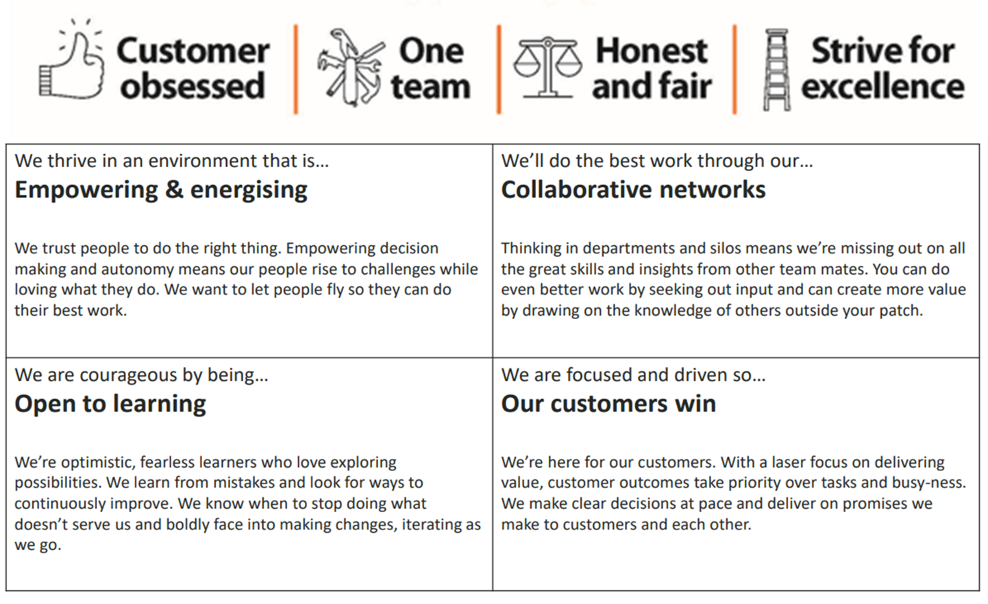
- Continue developing skills and knowledge relevant to the role.

