


POSITION DESCRIPTION
Your position title will be |  | Cafe Chef
You’ll be supported by |  | Café Manager & Head Chef
HOW YOU’LL HELP INSPIRE KIWI TO LOVE WHERE THEY LIVE, WORK AND PLAY
You will be focused on supporting the Head Chef in the overall day to day running of the Columbus Coffee kitchen. You will be actively contributing to the overall success of our business by maximising sales, profitability and being customer obsessed.
WHAT YOU’LL DELIVER
Customer service/POS operation
- Acknowledge all customers with a friendly, polite greeting and smile
- When using the POS maintain efficient, accurate cash handling and ensure the correct order has been taken
- Understand the process for all types of transactions including cash, eftpos, credit cards and gift vouchers
- Give correct change to enable accurate end of day balancing
- Be accountable for register contents in case of balancing queries by the finance department
- When processing orders at the POS ask customers if they are a Columbus Coffee member proceed to scan/search for them at POS so they can earn and redeem rewards and offers
- Offer customers the opportunity to join the Columbus Coffee loyalty programme
- Offer alternative solutions to dietary requirements to fulfil the customers’ needs
Operational
- Assist the Head Chef/Sous Chef in a professional manner contributing to the efficient running of the kitchen
- Assist in the store opening and closing procedures
- Assist and support the Head Chef in all areas
- Assist when required to develop and maintain cuisine concepts and standards for food preparation and presentation
- Prepare all customer orders with accuracy and in a timely manner
- Share responsibility for the kitchen and ensure the product in your area is replenished as required
- Maintain a high presentation standard with all cabinet food, enabling a seamless experience for our customers
- Check daily all food labels are correct i.e pricing & allergens are displayed accurately
- Inform FOH staff of any changes, shortages or menu items that cannot be offered
- Notify management of any shortages, surpluses and/or product requests, and arrange for stock to be re-ordered as requested
- Ensure the work area is clean, tidy and well presented in line with Brand Guidelines
- Communicate issues and concerns to the leadership team with a great sense of urgency
- Communicate effectively with all café team members
- Prepare and present meals as per Columbus Coffee Standards
- Establish and maintain the CORE standard of all menu & cabinet items
- Supervise and maintain quality control for outgoing meals, prompt FOH staff to seek customer feedback regularly
- Utilise and ensure effective shift handovers are communicated through group chats etc
- Ensure a high level of cleanliness is maintained in the entire kitchen area
- Follow and complete all iMonitor daily, weekly & monthly checklists
- Minimize wastage and recycle whenever possible
- Assist in creating ‘Blackboard Specials’ and help with the development of new cabinet plans
- Prioritize your assigned duties & task to ensure the smooth running of the kitchen
Stock management
- Follow all Health & Safety processes when accepting deliveries of frozen and refrigerated stock
- Try to reduce/minimise wastage by following par levels for ordering
Stock management continued
- Record wastage correctly
- Make recommendations on products to order when necessary
- Identify any stock or pricing issues and resolve in consultation with Head Chef/Café Manager
- Deal with faulty goods returns and credit as per café procedure ensuring safe handling and storage until it has been collected or resolved
- Assist with ordering daily stock
- Assist with stock take procedures accurately and efficiently at the end of the month
- Ensure stock rotation on items with expiry and/or best before dates
Team support
- Liaise with cafe team members to gain customer feedback
- Liaise with line managers to ensure department goals and targets are being achieved
- Communicate problems, resolved or unresolved to your Manager/Head Chef
- Engage in a positive team culture
- Actively monitor all applicable Columbus Coffee group chats
- A willingness to learn and help in other areas of the café when necessary
Self-Management and other duties
- Project a favourable Company image through personal appearance, knowledge, attitude and language
- Wear a clean and tidy Company uniform including a name badge
- Have a positive attitude with a general willingness to help
- Have a curiosity to grow your own personal knowledge and actively participate in personal training provided
- Take responsibility for personal time management to ensure that all required tasks are completed in a timely manner
- Maintain flexibility in your availability to support your team as required
- Any other duties or responsibilities that your manager feel are appropriate given your role and skills
Security/Loss prevention
- Full awareness of your surroundings to ensure the safety and security of yourself, store product and your teammates, reporting any suspicious characters or security concerns immediately to duty management
- Keep registers always closed and secure except when processing a transaction
- Follow the Customer Centred Service training to acknowledge every customer to act as a deterrent for those who are acting suspiciously.
- Complete the Loss prevention & Robbery prevention & safety skills” eLearning’s
Health & safety
- Demonstrate safe work processes and behaviours, ensure these are followed by all team members and contractors in their place of work
- Follow all controls governed by the Food Control Plan
- Adhere to the instructions of Fire Warden in the event of a Fire or Fire Drill
- Always be aware of health and safety risks. Take 10 seconds to pause and assess the risks before starting any work. If anything is different, unsafe or dangerous then address this immediately – speak to a manager if you need assistance
- Follow safe work practices, standard operating procedures, rules and instructions
- If there is something you don’t know, or if you have any health and safety concerns, ask your manager or the health and safety manager
- Only use equipment or do tasks you have been trained and are authorised for
- Use all safety gear (including PPE) that is needed for the task
- Maintain a clean and orderly work area
- Proactively participate in return-to-work plans if and when applicable
- In conjunction with the Health & Safety representative assist in any investigation within your department and ensure any corrective actions are implemented where you are assigned responsibility
- Be in a fit mental and physical state to do your job
- Report all injuries, incidents or anything unsafe (hazards) immediately (ecoPortal - Health, Safety & Wellbeing)
- Health & Safety reporting to Columbus Coffee
- Contribute to the overall safety culture by voicing your ideas and suggestions and developing solutions on health and safety performance and get involved with safety improvement activities
- Provide safety advice to team members and peers
Learning & development
- Adhere to completion dates for all relevant Mitre10 eLearning modules for your department
- Adhere to completion dates for all relevant Mitre10 Standard operating procedures for your department
- Adhere to completion dates for all Columbus Coffee eLearning
- Actively participate in your individual performance development review

Compliance management
- Adhere to Food Control Plan compliance checks as and when necessary i.e regular delivery temp checks, cooling temps, proven cooking method etc
- Adhere to Columbus Coffee Policies and Procedures
- Show integrity in following all Mitre10 ltd policies & procedures including all Health & Safety guidelines
- Maintain knowledge of the necessary legislative governances i.e Food Act 2014 and Food Control Plan
- Compliance with all internal and external policies and procedures that govern the store’s activities as they relate to your role.
- Communicate issues of concern to the Head Chef/Café Manager ensuring non-compliance is escalated and addressed
CORE CAPABILITIES YOU NEED | MINDSETS, HABITS AND BEHAVIOURS YOU NEED
- Deliver excellence in customer service acting in the best interests of the company  - Communicate with everyone effectively and carry out agreed solutions  - Create and maintain professional, friendly working relationships, sharing information as needed  - Ability to work on your feet for several hour at a time  - Ability to keep calm and work well in a fast-paced environment under pressure | - Flexibility and adaptability  - Be open to learning and look for ways to continuously improve.  - Be customer obsessed, ensuring they take priority over other tasks and busy-ness  - Present yourself positively, through personal presentation and attitude  - A passion for safe work processes and behaviours
TECHNICAL SKILLS YOU HAVE | YOUR ROLE SCOPE
- Understanding of health, safety, and wellness, along with relevant practices within hospitality and how to keep our team mentally and physically safe, along with our customers  - Comfort using a tablet and mobile devices  - Minimum 2 years cookery experience  - Current First Aid (desirable)  - Current Fire warden (desirable) | Number of direct reports:  Budget ownership: Nil
HOW WE DO THINGS HERE AT MITRE 10
- We live by our values in how we are with one another as one team and with our customers
- We all play an active part in our health, safety & wellbeing obligations, following guidelines and procedures and always working in a safe way
- We all know the guidelines we’re working within to help us stay on track (policies and procedures)
- We all muck in and help with whatever needs doing

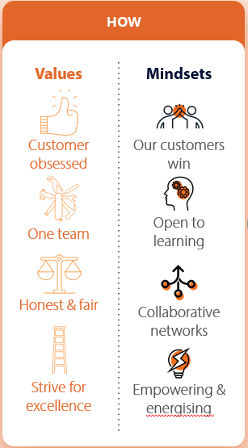

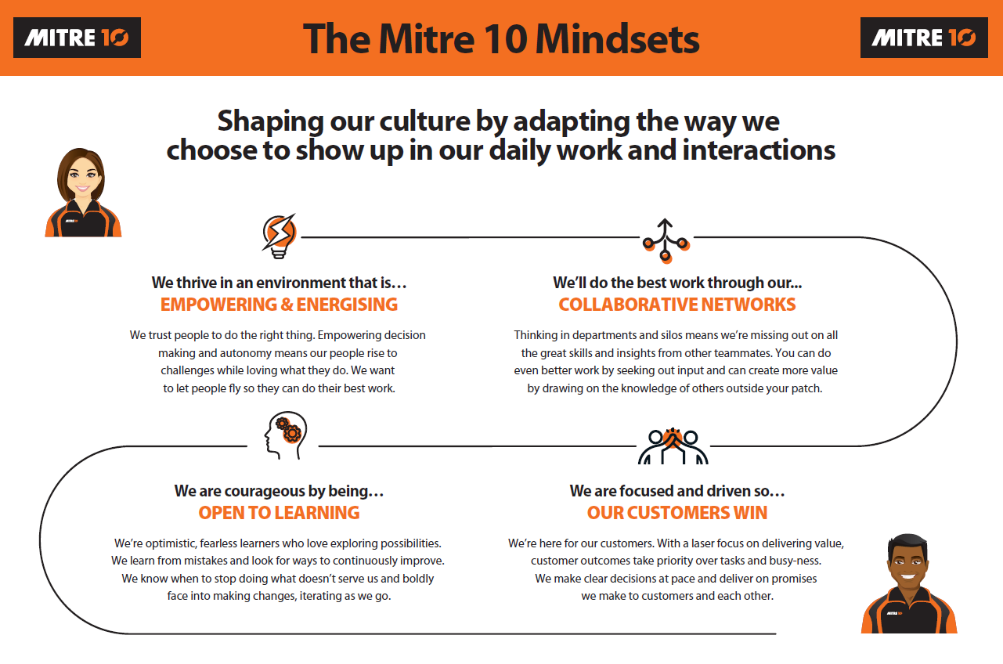
YOUR ACKNOWLEDGEMENT
Name:
Signed:
Date:

