


POSITION DESCRIPTION
Your position title will be |  | Cafe Front of House Team Member
You’ll be supported by |  | Café Manager
HOW YOU’LL HELP INSPIRE KIWI TO LOVE WHERE THEY LIVE, WORK AND PLAY
You will be focused on being a team player helping the day to day operation of the Café in an effective and efficient manner. You will be actively contributing to the overall success of our business by maximising sales, profitability and being customer obsessed.
WHAT YOU’LL DELIVER
Customer service/POS operation
- Acknowledge all customers with a friendly, polite greeting and smile
- Efficient and accurate cash handling, ensuring confirmation of the correct order
- Understanding of the process for all types of transactions including cash, eftpos, credit cards, gift vouchers
- Give correct change to enable accurate end of day balancing
- Be accountable for register contents in case of balancing queries by the finance department
- When processing orders at the POS ask customers if they are a Columbus Coffee loyalty member proceed scan/search for them at POS so they can earn and redeem rewards and offers
- Offer the customer the opportunity to join the Columbus Coffee loyalty programme
- Personally own, act and solve problems and complaints. Recognise this as an opportunity for growth
- Maintain a high level of product and service knowledge in order to explain and sell services
- Provide efficient and memorable level of service to all customer
- Up-sell food and beverage products
Operational
- Follow the store opening and closing procedures as per Columbus Coffee Standards and checklist
- Maintain, follow and present Brand Standard cabinet food, menu items, cold & hot beverages
- Ensure the FOH dining area is tidy and well presented in line with Brand Guidelines
- Communicate any issues and concerns to the management team with a great sense of urgency
- Communicate effectively with all team members
- Seek customer feedback regularly
- Utilise and ensure effective shift handovers are communicated through group chats etc
- Assist with completion of iMonitor daily, weekly & monthly checklist with your team
- Minimize wastage and recycle whenever possible
- Effectively interact with internal & external customer to anticipate needs of the business
- Assist with all requirements for the acceptable standards for Store Audit reports
- Communicate to management any equipment/machinery that is not working correctly
- Keep yourself up to date with marketing and promotional offers
- Respond to all customer request in a professional and timely manner
- Maintain and high level of food and general hygiene practice at all times
- Perform duties as per the daily deployment sheet and management requests
- Maintain stock levels of cold beverages and other supplies in fridge, freezer, counter and storeroom
- Advise management of stock shortages to reorder
- Maintain general housekeeping tasks
- Monitor Barista/counter requirements for cups, plates, saucers, cutlery, to ensure service times are maintained
- Actively clear and clean tables promptly throughout the day
- Follow all Health & Safety processes when accepting deliveries of frozen and refrigerated stock
- Record wastage correctly
- Deal with faulty goods returns and credit as per café procedure ensuring safe handling and storage until it has been collected or resolved
Operational continued
- Ensure stock rotation on items with expiry and/or best before dates is maintained by all FOH staff
Team support
- Attend staff meetings, use this as an opportunity to share ideas, opinions and raise any concerns
- Communicate problems, resolved or unresolved to the Café Manager
- Engage in a positive team culture
- Actively monitor and utilize all applicable Columbus Coffee group chats
- Support all team members have a to learn and help in other areas of the café when necessary
Self-Management and other duties
- Project a favourable Company image through personal appearance, knowledge, attitude, and language
- Wear a clean and tidy Company uniform including a name badge
- Adhere to Columbus Coffee Company Code of Conduct
- Ensure a high level of cleanliness is maintained in the business
- Develop/update skills internally and externally to reflect changed technology or changed work requirements
- Have a positive attitude with a general willingness to help
- Have a curiosity to grow your own personal knowledge and actively participate in personal training provided
- Maintain flexibility in your availability to support your team as required
- Take responsibility for personal time management to ensure that all required tasks are completed in a timely manner
- Actively interact with internal Mitre10 Mega staff and external customers to anticipate needs and determine service delivery levels
- Keep personal discussions to a minimum.
- Any other duties or responsibilities that your manager feel is appropriate given your role and skills
Security/Loss prevention
- Full awareness of your surroundings to ensure the safety and security of yourself, store product and your teammates, reporting any suspicious characters or security concerns immediately to duty management
- Keep registers always closed and secure except when processing a transaction
- Complete the Loss prevention & Robbery prevention & safety skills” eLearning’s
- Follow the Customer Centred Service training to acknowledge every customer to act as a deterrent for those who are acting suspiciously.
Health & safety
- Direct contractors & visitors when reporting to management to ensure correct signing in & out procedures are being followed.
- Practice safe work processes and behaviours, ensure these are followed by all team members and contractors in their place of work
- Follow all controls governed by the Food Control Plan
- If there is something you don’t know, or if you have any health and safety concerns, ask your Manager or the Health and Safety Manager
- Always be aware of health and safety risks. Take 10 seconds to pause and assess the risks before starting any work. If anything is different, unsafe or dangerous then address this immediately – speak to a manager if you need assistance
- Follow safe work practices, standard operating procedures, rules and instructions
- Only use equipment or do tasks you have been trained and are authorised for
- Use all safety gear (including PPE) that is needed for the task
- Maintain a clean and orderly work area
- Be in a fit mental and physical state to do your job
- Participate in your return-to-work meetings when applicable
- Report all injuries, incidents or anything unsafe (hazards) immediately (ecoPortal - Health, Safety & Wellbeing)
- Contribute to the overall safety culture by voicing your ideas and suggestions and developing solutions on health and safety performance and get involved with safety improvement activities
- Follow up safety concerns brought to your attention and report back outcomes to the person/s concerned
Learning & development
- Play an active role in the development and training of staff
- Play an active role in the in-store training and development of new skills
Learning & development continued
- Adhere to completion dates for all relevant Mitre10 eLearning modules
- Adhere to completion dates for all relevant Mitre10 Standard operating procedures
- Adhere to completion dates for all Columbus Coffee eLearning
- Actively participate in your individual performance development review
Compliance management
- Adhere to Food Control Plan compliance checks as and when necessary i.e regular delivery temp checks, cooling temps, proven cooking method etc
- Maintain knowledge of the necessary legislative governances i.e Food Act 2014 and Food Control Plan
- Adhere to Columbus Coffee Policies and Procedures
- Show integrity in following all Mitre10 ltd policies & procedures including all Health & Safety guidelines
- Compliance with all internal and external policies and procedures that govern the store’s activities as they relate to your role.
- Communicate issues of concern to the Café Manager ensuring non-compliance is escalated and addressed
- Adhere to Mitre10 and Columbus Coffee employment practices
CORE CAPABILITIES YOU NEED | MINDSETS, HABITS AND BEHAVIOURS YOU NEED
- Deliver excellence in customer service acting in the best interests of the company  - Communicate with everyone effectively and carry out agreed solutions  - Create and maintain professional, friendly working relationships, sharing information as needed  - Ability to work on your feet for several hours at a time  - Ability to keep calm and work well in a fast-paced environment under pressure | - Flexibility and adaptability  - Be open to learning and look for ways to continuously improve  - A passion for safe work processes and behaviours  - Present yourself positively, through personal presentation and attitude  - Be customer obsessed, ensuring they take priority over other tasks and busy-ness
TECHNICAL SKILLS YOU HAVE | YOUR ROLE SCOPE
- Understanding of health, safety, and wellness, along with relevant practices within hospitality and how to keep our team mentally and physically safe, along with our customers  - Comfort using computer and mobile devices  - Knowledge of relevant legislative governances  i.e., Fair Trading Act, Consumers Guarantee Act etc., and act in accordance with them  - Current First Aid (desirable) | Number of direct reports: 0  Budget ownership: Nil
HOW WE DO THINGS HERE AT MITRE 10
- We live by our values in how we are with one another as one team and with our customers
- We all play an active part in our health, safety & wellbeing obligations, following guidelines and procedures and always working in a safe way
- We all know the guidelines we’re working within to help us stay on track (policies and procedures)
- We all muck in and help with whatever needs doing

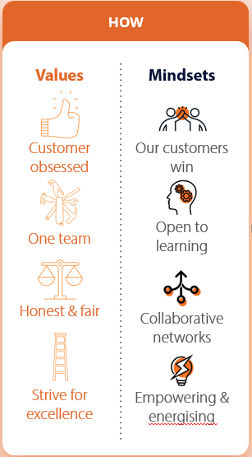

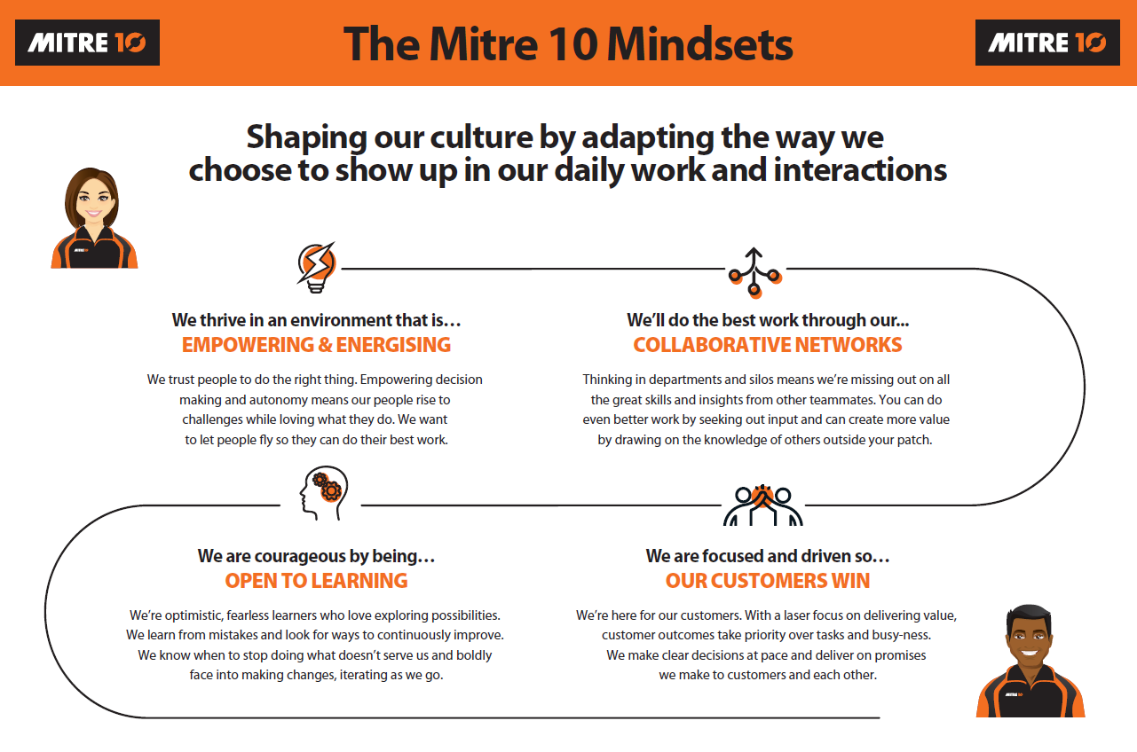
YOUR ACKNOWLEDGEMENT
Name:
Signed:
Date:

