
POSITION DESCRIPTION

POSITION DETAILS
Position Title | Head of Department (HOD)
Supported By | Retail Manager / Operations Manager
Date | February 2023

PURPOSE STATEMENT

To maximise sales and profit by supervising team members in a way that ensures accurate merchandising, pricing and stock integrity and encourages excellent customer service.

KEY ACCOUNTABILITIES OF POSITION
Accountability Description | Measure |  | Weighting
1: Team and Sales Management | Manage department team members in a way that maximises their productivity, and quality of work  - Supervise and provide direction to department staff members.  - Achieve sales and margin targets.  - Monitor performance and provide regular feedback including 6 monthly appraisals.  - Identify and implement required induction and ongoing training.  - Have systems in place to ensure team members are kept up to date with the latest company policies, procedures and promotions.  - Develop a succession plan for your department and develop staff towards their full potential.  - Lead by example  - Encourage each team member to be actively involved in a store committee  - Ensure team members work in a safe manner at all times  - Develop a positive culture of outstanding customer service and store presentation within your team.  - Create staff rosters ensuring appropriate cover is maintained within the zone during store opening times based on hour by hour sales reports.  - Allocate daily duties to Staff Members using the department daily walkthrough book. |  | %
2: Customer Service | Provide customers with the highest standard of service at all times  - Ensure customers are the number one priority  - Acknowledge all customers within a 3 metre radius  - Answer customer enquiries and seek assistance when necessary  - Make enquiries as to the customer’s project, provide specific product knowledge and give advice on the most suitable product for their circumstances  - Apply the GREAT principal at all times  G reet the customer  R espond to them  E mpathise with them  A sk for the Sale / add-ons  T hank them  - Answer the telephone in a polite and helpful manner, within 4 rings  - Take rain-checks or order product in for customers when required  - Deliver the Mitre10 Price Promise  - Understand and deliver the Easy As customer experience throughout the store.  - Understand and drive the Customer Centred service and culture throughout the store.  - Ensure the department desk area is maintained in a clean and tidy manner at all times. |  | %
3: Operational Management | Ensure the store is effectively managed and maintained at all times  - Ensure the highest standard of service is provided to both internal and external customers at all times  - Deal promptly with all complaints to ensure customer satisfaction is maintained  - Provide day-to-day leadership of team members  - Assist in managing the store in a professional manner and take responsibility for the efficient running of the store in the absence of the Retail/Operations Managers.  - Actively participate in Duty Management of the store, including responsibility for key holding.  - Actively assist in store opening and closing procedures, including being rostered for these duties when requested.  - Be able to give advice on product knowledge, queries, stock, merchandising, pricing and promotions whenever needed  - Ensure the store adheres to Company and legislative operating policies and procedures, e.g. housekeeping, merchandising. Constantly review working practices and recommend improvements.  - Ensure all specified security procedures and policies are adhered to  - Ensure cash handling routines are adhered to at all times
4: Merchandising | Have the overall responsibility of all stock movement, displays, POS and general standards in the department  - Ensure stock is merchandised correctly to take advantage of impulse sales.  - Ensure EXPOs are tied up on time and arrange any supporting activities to coincide with these events (eg. Face painting or bouncy castle)  - Ensure displays adhere to Company guidelines.  - Ensure POS is current.  - Ensure all products are ticketed with the correct size ticket, at the current price.  - Report to management any unusual, extreme or unacceptable price or stock variations.  - Maintain outstanding housekeeping standards. |  | %
5: Stock Management | Have the overall responsibility of all stock movement in and out of the department  - Maintain core compliance in your department.  - Ensure stock is rotated as required.  - Ensure sufficient stock is ordered to support promotions.  - Make recommendations on products to order.  - Liaise with inventory control and management to ensure your department has the correct stock in suitable quantities for the given run rate.  - Ensure effective and accurate stock takes.  - Maintain a good relationship with suppliers keeping updated on new products available.  - Ensure all items in stock are on display.  - Manage SLOB stock to acceptable levels.  - Keep the team updated on upcoming promotions and ensure promotions are tied up suitably and on time and removed on time.  - Be aware of competitor activity and promotions and react accordingly in consultation with management.  - Ensure recently received stock is merchandised into the department in a timely manner.  - Identify any stock or pricing issues and resolve in consultation with inventory management.  - Process damaged stock / returns in accordance with Company policy |  | %
6: Administration / Reporting | Have overall responsibility for ensuring all administration processes are completed accurately and efficiently  - Ensure incoming and outgoing stock is processed correctly.  - Ensure the correct files and folders are kept for each department.  - Assist accounts payable and payroll with enquiries.  - Present reports to your line manager as and when required and by the deadline specified.  - Attend meetings as requested. |  | %
7: Profit Protection & Loss Prevention | - Contribute to the overall success of the Company through minimizing shrinkage by following all store process, procedures around loss and actively supporting the Loss Prevention Committee.  - Participate in the Loss Prevention Committee as required  - Familiarise yourself with all vulnerable areas and product lines  - Maintain an awareness of those people that present a shrinkage risk to the store  - Be vigilant at all times to reduce theft  - Actively participate in training provided
8: General | Fulfil other duties as required  - Ensure the highest standard of service is provided to customers at all times.  - Liaise with line manager to ensure department goals and targets are being achieved and that Company policies are complied with.  - Maintain an awareness of loss prevention within your team.
9: Compliance Management | - Understand and adhere to all compliance requirements, internal & external, that govern the Company’s activities  - Comply with Mitre10 Mega policies and procedures
10: Health & Safety | Demonstrate safe work processes and behaviours, and ensure these are followed by all team members and contractors in their place of work  - Report all safety performance, safety programmes, compliance, risks and serious incidents  - Ensure compliance with stores safety procedures and standards.  - Specific activities should include:  - Ensure daily plant and operational checks are completed  - Ensure all incidents are recorded  - Attend safety meeting as required  - Ensure corrective actions are implemented  - Encourage team members to be involved in all safety activities, including reporting of new hazards  - Ensure all employees are using PPE as required and are trained using SOP’s  - Quickly follow up team members/individual safety concerns  - Ensure all team members are fit for work  - Inspect the workplace each day  - Provide safety advice to team members and peers
FINANCIAL & PROJECT DIMENSIONS
Total Revenue accountability |  | Nil
Annual Operational Expense Budget |  | Nil
Annual Capex Budget |  | Nil
Expenditure authority maximum |  | Nil

POSITION HOLDER SPECIFICATIONS
Qualifications required | Level 4 Retail qualification, or relevant experience
Total years of experience required | 1-3 years in a leadership level role
Other specific technical skills required (e.g. excel)
Competencies required:

KEY PERFORMANCE STANDARDS
People  (i.e. development & learning, including eLearning, coaching, feedback, performance reviews etc) | - Effectively coach to improve their knowledge and application of products.  - Commit to growing and developing your people, ensuring they complete a range of eLearning modules (and other learning solutions) to increase their knowledge and ultimately increasing sales and service.  - Regularly giving constructive feedback on their interactions with others.  - Carrying out regular performance reviews, explaining clearly expectation of  - performance and standards, setting key objectives that are linked to the organisation’s strategy and holding people to account.  - Drive and implement the Mitre10 VPV culture throughout the store.
Customer | • Helping my team to maximise use of their skills and knowledge with customers and colleagues every day.  • Using my knowledge, experience and relationships to increase my team and customer engagement.  • Serving customers in any area of the store where there is need and leading by example and coaching team members whilst doing so.  • Driving initiatives such as Easy AS.
Sales & Profitability  (i.e. Loss prevention, Sales & budget  P&L understanding  Gross margin etc) | - Achieve and/or exceed sales and margin targets  - Create and drive a culture of awareness around shrink and profit protection  - Achieve 90%+ on Mystery Shopper Report  - 90% on department checklist audit  - Zero complaints  - Knowledge and skills of Staff Members  - Maintenance of manning levels  - Unexplained shrinkage less than 1% of sales  - Store Margin consistently above 30%
Operations  (i.e. processes, operating procedures, compliance - includes H&S etc) | - Ensure incoming and outgoing stock is processed correctly.  - Ensure the correct files and folders are kept for each department.  - Assist accounts payable and payroll with enquiries.  - Present reports to your line manager as and when required and by the deadline specified.  - Attend meetings as requested.
Stock  (i.e. product, inventory control  availability, gap analysis, presentation) | I always make products in my store available for customers by:  - Ensuring teams are confident to use GOOD, BETTER, BEST to offer alternative products.  - Training my team on ways to increase sales through stock availability such as, GAP Management, Stock Takes, Negative Stock and Bin Location processes.  - Regularly giving constructive feedback and coaching my team on presentation standards.  - Coaching colleagues to improve their application and understanding of our merchandising principles.  - 95% Core compliance  - SLOB stock less than 5%  - Zero damaged stock  - 95% accuracy of pricing & labelling  - Make contact with suppliers once a month

HOW WE DO THINGS HERE AT MITRE 10
- We live by our values and mindsets in how we are with one another as one team and with our customers
- We all play an active part in our health, safety & wellbeing obligations, following guidelines and procedures and always working in a safe way
- We all know the guidelines we’re working within to help us stay on track (policies and procedures)
- We all muck in and help with whatever needs doing


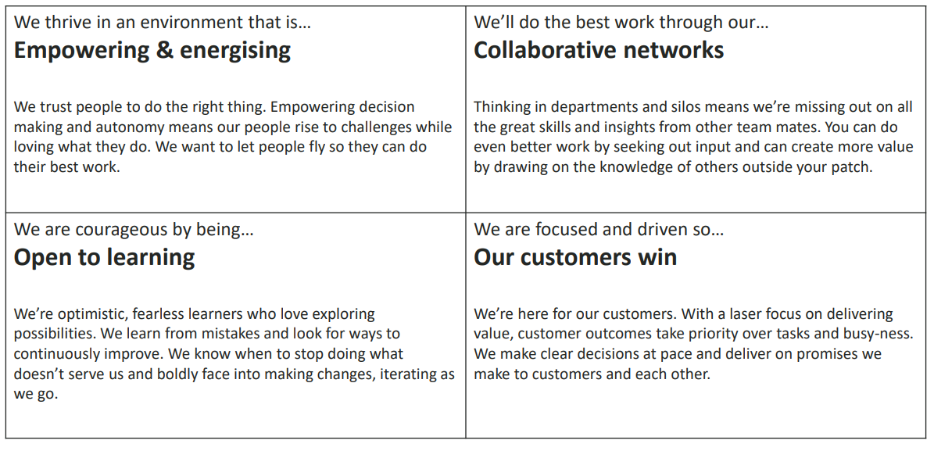

ORGANISATIONAL STRUCTURE
