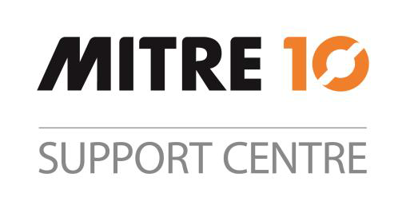
POSITION
DESCRIPTION

Your position title will be: | Category Assistant
You’ll be supported by: | Category Manager
Your team mates will be: | Merchandise
HOW YOU’LL HELP INSPIRE KIWI TO LOVE WHERE THEY LIVE, WORK & PLAY
You will be responsible for playing a pivotal role in supporting the success of our marketing strategies and category projects by coordinating advertising, promotions, and programs for retail and trade channels. You will collaborate closely with stores, the marketing team, and Category Managers to ensure seamless communication, alignment of objectives, and effective execution of initiatives.

ACCOUNTABILITY DESCRIPTION
- Delivery (80%) | - Coordinate promotional programs across various media platforms and in-store, including the Bulk Merchandise Program (BMP).  - Manage timelines and communicate with Category manager (CM) / Assistant Category Manager (ACM) for all promotion activities.  - Organize product submissions for National Retail and trade promotions, inputting them into schedules and selection sheets.  - Ensure accuracy of advertising content and visuals for all media promotions.  - Collaborate with suppliers, stores and marketing for promotion coordination.  - Create and distribute promotional collateral such as store ordering spreadsheets.  - Generate promotional reports including item availability and sales uplift.  - Allocate promotional lines per CM instructions with approvals as required.  - Support Category Manager with suppliers by issuing DIFOT reports, assisting with on boarding suppliers to point of sale tool (POS) & supplier portal access, running price indexing reporting for key suppliers and opening new accounts (when applicable).  - Respond to customer and store enquires in line with the sundown rule.  - Assist Category Managers with supplier scorecard management.  - Manage, update and communicate price changes to stakeholders.
- Self Leadership (10%) | - Provide constructive feedback and share knowledge with other team members.  - Actively participate in 1:1’s and Perform, Grow, Succeed conversations.  - Demonstrate Values and Mindsets
- Administration (10%) | - Support the Data team with collation of data and image information for new SKU creation.  - Maintenance of SKU integrity and Mitre 10 Net data in conjunction with the Product Data team/Stockfile.  - Assist the Category Manager, Category Suppliers and data team with co-ordination and the uploading of price changes in the Lansa system.  - Attend supplier meetings, when required, record minutes and assist in follow up requests.  - Working with Store Operations to maintain visual guide content.

CORE CAPABILITIES YOU NEED | TECHNICAL SKILLS YOU HAVE
- Intermediate administration support experience.  - Excellent verbal and written communication skills.  - Customer centric; internally and externally.  - Attention to detail.  - Proven ability to complete multiple tasks on time in full. | - Excellent skills with an inventory management and content management system. (eg Lansa)  - Intermediate-advanced computer skills- the Microsoft suite, digital collaborative tools such as Confluence, SharePoint.  - Advanced skills with Microsoft Excel.

HOW DO WE DO THINGS HERE AT MITRE 10
- We live by our Values and Mindsets in how we are with one another as one team and with our customers.
- We all play an active part in our Health, Safety & Wellbeing obligations, following guidelines and procedures and always working in a safe way.
- We all know the guardrails we’re working within to help us stay on track (policies and procedures)
- We all muck in and help with whatever needs doing.



