**Mitre 10 MEGA Hornby**

**Service Support Team Member Position Description**

**What is Service Support?**

**Service Support**

Service support is a role to assist Mitre10 MEGA Hornby in achieving high service standards to our customers and community, this role has a direct impact on how customers shop with in our store and has high standards that need to be meet, under service support there is multiple different duties which lay with the team to maintain and action to a high standard.

**Service Support Tasks**

* General store task’s (Retail Managers to advise on)
* Customer lifting requirements (Service support calls “C/outs”)
* General Service support duties, Trollies, Rubbish bins (Work sations / store)
* Stock
* Hot Spot bays (Service support / Stock Fill team’s)

**All tasks require only one team member to complete at any given time, unless advised by a manager. You will not need to be working in groups, to complete normal “Service Support” Duties**

**Service Support (Weekdays) 4pm – 7pm**

Duties required to be completed on weekdays are the same as weekends, but weekdays generally have less customer tasks to be completed.

When you get to work for your rostered shift (4pm – 7pm) make sure to **clock in** before you start then head down to the floor, when you get to the shop floor touch base with the duty manager that is on and see if there is anything critical, they need actioned, if nothing go to your general duties.

* Trollies
* Store Waste (Breakdown Below)
* Cardboard Bins
* Pot Recycling, Lightbulb Recycling, Polystyrene Bins
* Floor sweeping (Scrub / Sweep)

**Service Support (Weekends)**

Duties required to be completed on weekends are the same as weekdays, but weekends have more customer tasks to be completed.

When you get to work for your rostered shift, make sure to **clock in** before you start then head down to the floor, when you get to the shop floor touch base with the duty manager that is on and see if there is anything critical, they need actioned, if nothing go to your general duties.

**7.00am Start** – Assist Opening manager to get the store ready to be opened, this will be any task required by the manager on.

* Rubbish sweep of carpark
* Store Rubbish / MEGA Centre (Harvey Norman) “**If not completed previous Night**”
* front of store displays (Moved outside)

**8.00am Start-** Check in with duty manager upon starting to see if any critical task required to be completed before starting normal duties

* Trollies
* Customer lifting requirements **(Can we get service support to “Area Called out “)**

**9.00am / 10.00am Start -** Check in with duty manager upon starting to see if any critical tasks required to be completed before starting normal duties, assist with floor tasks throughout the day, towards end of shift move to closing duties

* Trollies (All trollies to be bought inside before store closes 7pm)
* Store waste (Breakdown Below)
* Foyer Display items (Outside) to be brought inside
* Cardboard Bins
* Floor sweeping (Scrub / Sweep)

**Reminder: You need to be bringing in at least 3 or more trollies in at a time, and be actively looking around the store for trollies if none in the carpark**

**Floor Sweeper & Scrubber**

(Machines Located in Drive Thru / Keys Located in Managers Office)

Both the floor Sweeper & Scrubber are used within the store to clean the floors, and to clean up any unwanted mess. Each night during your shift, all retail floors need to be swept, this is to keep our store well presented for our customers

**Floor Sweeper**

Used to “Sweep” the floors, Retail, Drive Thru & Garden Centre.

**This is not to be used on wet floors)**

**Floor Scrubber**

Used to “Scrub” the floors in conjunction with the floor sweeper, The floor scrubber can only be used on (Polished) floors ‘Retail”

**This is not to be used in the Garden centre or exterior concrete of the store**

|  |  |  |
| --- | --- | --- |
| **Weekends**  (Morning’s “If Required”)  (Night “Between 4pm – 7pm) | **Weekdays**  (Between 4pm – 7pm) | **General Use**  (When advised By Manager) |

**Important Note: These machines are not to be used unless correct training has been given, and you are signed off**

**Store Waste**

All store waste to be collect each night, and/or when required. This will be apart of your normal service support duties. Rubbish bags are located in downstairs cleaning cupboard (By public toilets)

**Workstations**

All departments across the store have general waste bins, these are scattered throughout the store (Bin location map – Below) these need to be emptied each night, this is to ensue we dont have messy workstations for the next day’s trading, and we maintain a clean working enviroment.

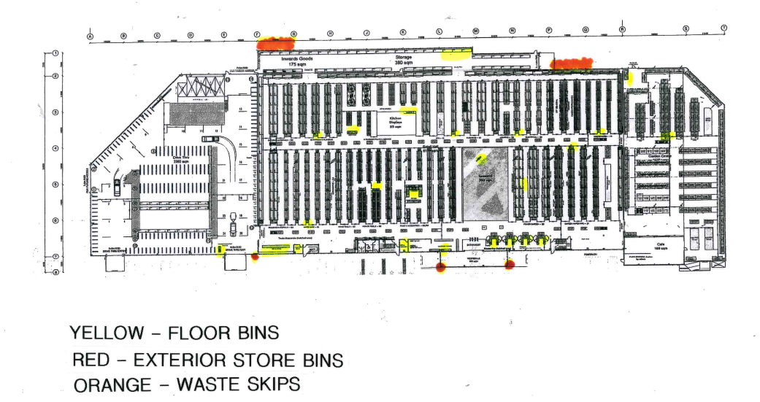

**Upstairs Offices**

(Executive Offices, Admin, Training Rooms, Team Break Room, Toilets, Hallway offices “Katherine, Small Meeting rooms, Liam’s Office” Support Office & Smokers Deck**)**

All upstairs offices have rubbish bins, these also need to be emptied each night to maintain a clean working enviroment. Start at the Executive Office (Andrew Smiths) office then work your way toward the support office end, ensuring you collect all rubbish along your way.

**Cardboard Bins**

Along with the work station bins, we have cardboard bins located at the back of the store (1st Bin located behind RTA, 2nd Bin Located Behind Housewares) these also need to be emptied each night while you are doing your service support duties. During the weekend these will also need to be emptied throughout the day.

**Supporting Our Customers**

As part of your role “Service Support” your main duty is to assist our customers with supporting them to ease their shopping experience while they are with us.

**What does this look like?**

Support Call’s (Can We Have Service Support To “Area in Store”)

This will be one of the main calls you get over the instore paging system, when you hear this call, you need to prioritise getting to the area of store you are called to **ASAP**, this is to ensure we are helping our customers with there requirements.

Lifting goods (Purchased Items) to their vehicle, and/or out of to bring into the store

A quick reminder that you will also need to be actively looking to support our customers, if you are bringing trollies in over the weekdays & weekend, please look to see who needs help, if you notice that a customer has a large item go over and assist them with getting that either to the c/outs or their vehicle, or if you see someone who looks like they need a hand, go and help them.

**Every Customer, Every Time**

**You are wearing our team uniform (Mitre10 Orange) this means you need to hold yourself to a high standard, your actions affect everyone not just you, if you are rude or don’t acknowledge a customer, this looks bad for everyone.**

**Service Support Role Sign off**

By signing this document, you acknowledge that you have read all the points stated around your role, and you understand what is required of you in the “Service Support” Role.

**Team Member Name:** ______________ **Signature:** ___________________________________

**Date:** / /2023

**Team Manager Name:** Lisa Grant **Signature:** ___________________________________

**Date:** / /2023